Six knowledge points:
1 What is agile method? What is the difference between agile development and Plan-driven development?
Agile method is a practice that promotes continuous iteration of development and testing throughout the software development lifecycle of the project. Both development and testing activities are concurrent unlike the Waterfall model

In this SDLC model requirements and solutions evolve through collaboration between various cross functional teams. This is known as an iterative and incremental model.

2. Please list all the principles of agile methods.
- Individual and team interactions over processes and tools
- Working software over comprehensive documentation
- Customer collaboration over contract negotiation
- Responding to change over following a plan

3. Please list all the Extreme programming practices.
- Pair Programming
- Planning Game
- Continuous Process
- Coding Standards
- Sustainable Pace
- Test Driven Development

4. The extreme programming release cycle
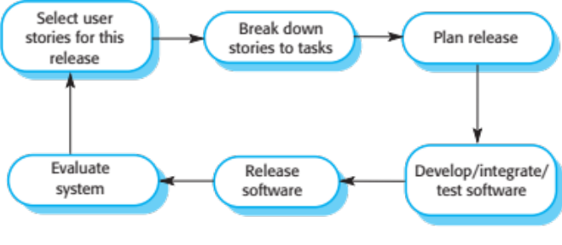

5. Please give an example about user stories for requirements.
- a customer or user is part of the XP team and is responsible for making decisions on requirements.
- User requirements are expressed as user stories or scenarios.
- These are written on cards and the development team break them down into implementation tasks. These tasks are the basis of schedule and cost estimates.
- The customer chooses the stories for inclusion in the next release based on their priorities and the schedule estimates.

- what is Scrum? Please explain three phases in Scrum.
Scrum an agile development method which concentrates specifically on how to manage tasks within a team-based development environment. Basically, Scrum is derived from activity that occurs during a rugby match.

Three phases:
- Scrum Master
  - Master is responsible for setting up the team, sprint meeting and removes obstacles to progress
- Product owner
  - The Product Owner creates product backlog, prioritizes the backlog and is responsible for the delivery of the functionality at each iteration
- Scrum Team
  - Team manages its own work and organizes the work to complete the sprint or cycle

